Tayla Potgieter

Shadows

User Guide for CTU-Buddy

Contents

Introduction: 2

Getting Started 2

Navigating the Website 2

Home page 2

Profile page 3

About Us 4

Contact Us 5

The subscription page 6

Calendar 6

Timetable 7

Discussion page 8

Share resources page 9

The URL 10

Download the website code 10

# Introduction:

The purpose of the CTU Buddy is to provide students with a professional and straightforward user-friendly platform. It serves as an invaluable tool in fostering academic success and facilitating an enhanced learning environment at CTU. The platform aims to assist students in efficiently managing their timetables, actively engaging in discussions, easily sharing resources, and effectively connecting with their peers and educators. Overall, the CTU Buddy aims to create a seamless and efficient platform that empowers students to excel in their academic journey while promoting productive collaboration and communication within the CTU community.

These user guides provide an opportunity to educate users about the full range of features and capabilities of the website. A user guide can help preempt common user questions and issues, reducing the volume of support requests or inquiries. This user guide improves the overall user experience by providing clear, step-by-step instructions on how to use the website effectively.

# Getting Started

A user-friendly and aesthetically pleasing timetable design utilizing HTML tables and CSS. It displays the date, time, modules, and days of the week for students to access their weekly schedules easily. The responsive design ensures seamless functionality across devices. Integrates a contact form for users to submit inquiries, suggestions, or feedback. It also includes a map showcasing the CTU campus location, enhancing user experience.

# Navigating the Website

## Home page

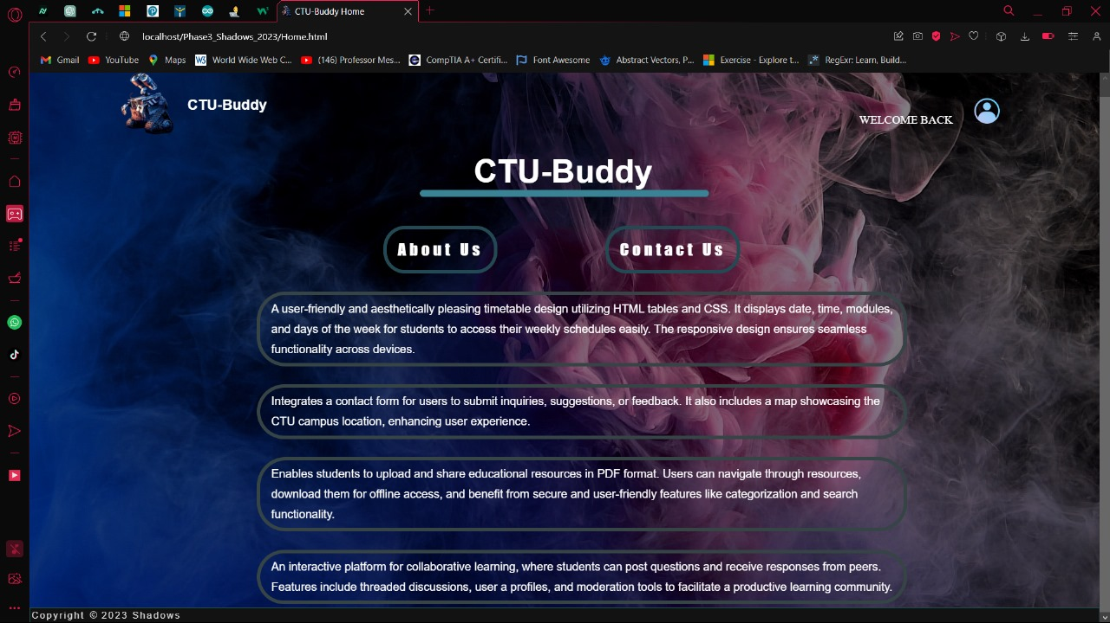

2

4

3

1

1. The wall-e picture refreshes the page.
2. This will take you to the profile page.
3. This button will take you to the About Us page.
4. This button will take you to the Contact Us page.

## Profile page

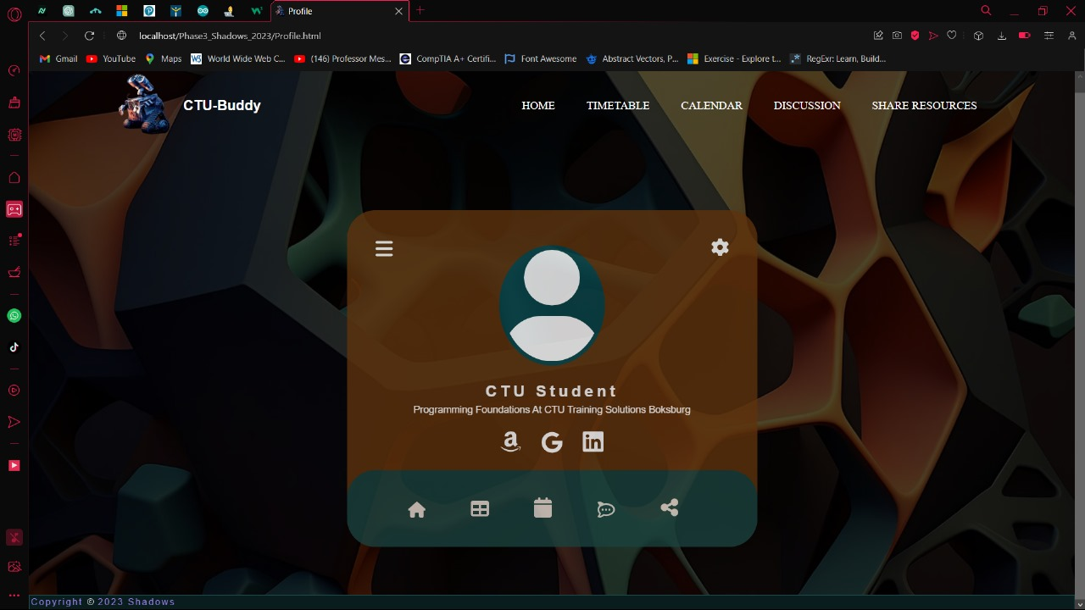

6

5

4

3

2

1

6

5

4

3

2

1. This wall-e will take you to the home page.
2. This button will also take you to the home page.
3. This button will take you to the timetable.
4. This button will take you to the calendar.
5. This button will take you to the discussion page.
6. This button will take you to the share resources.

## About Us

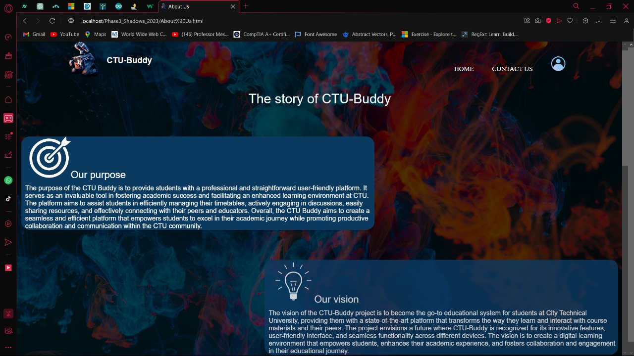

4

3

2

1

1. This wall-e will take you to the home page.
2. This will also take you to the home page.
3. This will take you to the Contact Us page.
4. This will take you to the profile page.

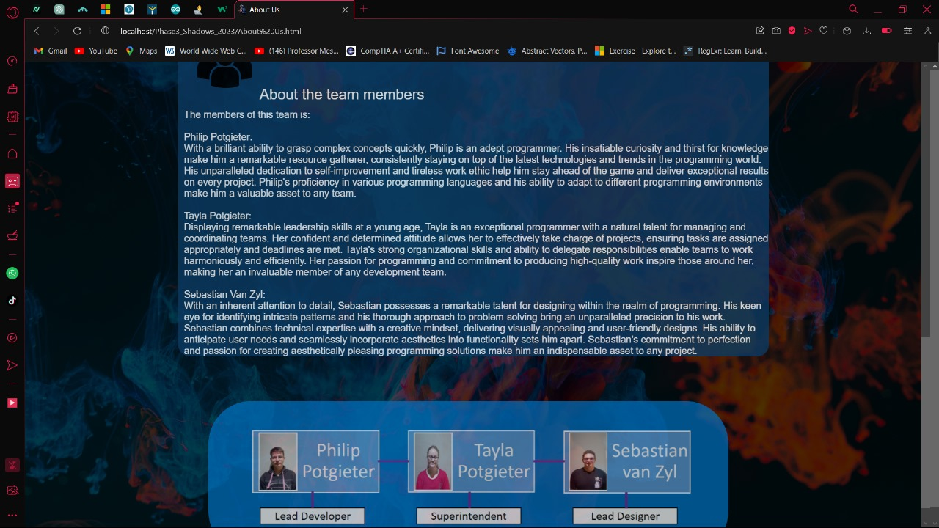

1

1. This is our team.

## Contact Us

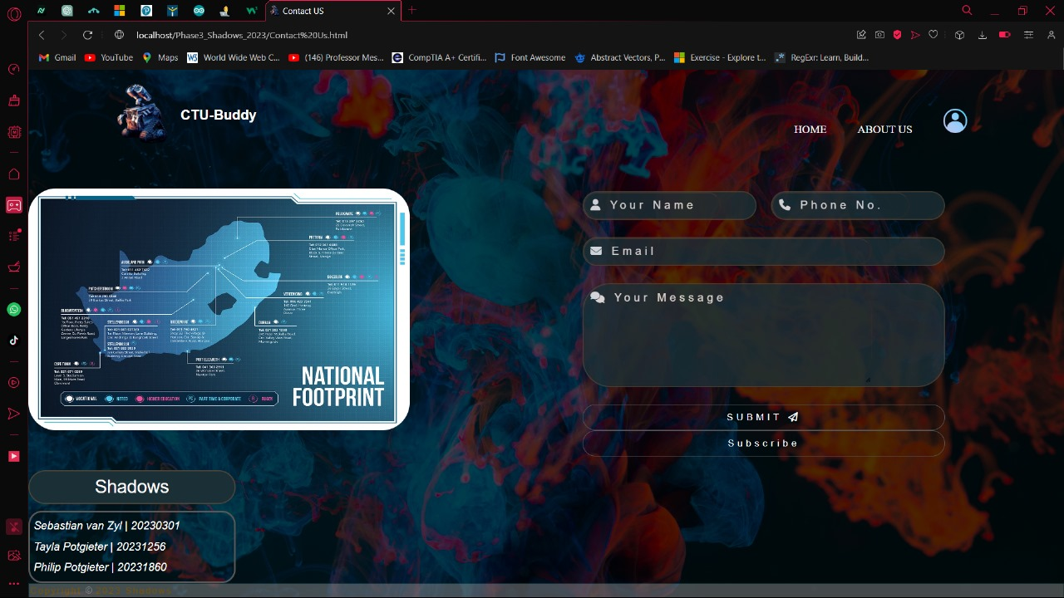

7

5

6

2

3

4

1

1. This wall-e will take you to the home page.
2. This will also take you to the home page.
3. This will take you to the About Us page.
4. This will take you to the profile page.
5. This is our map of where all the CTU facilities are located.
6. This is where you put your details to get in contact with us.
   1. Your name: put your first name here.
   2. Phone no: put your phone number here.
   3. Email: put your email address here.
   4. Your message: put the message you want to send us here.
   5. submit: this button will send your details and message to us.
7. This subscribe button will send you to our newsletter subscription.

## The subscription page

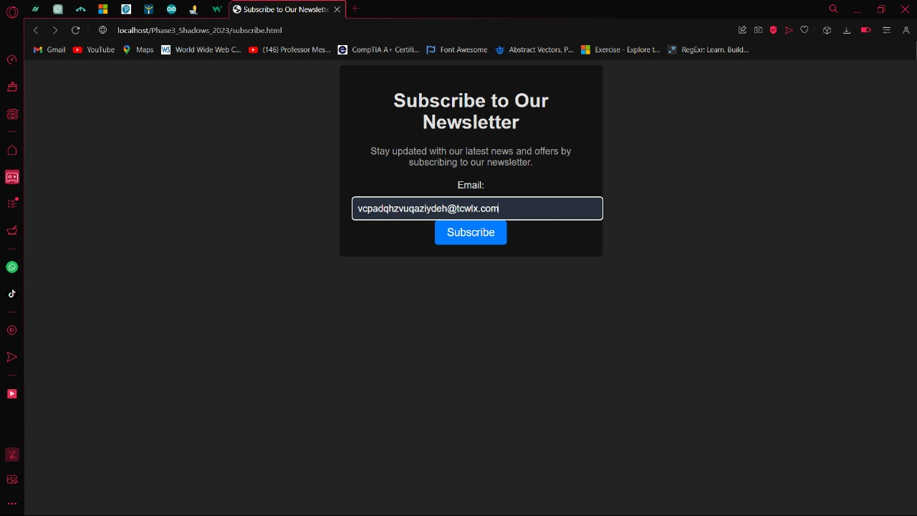

2

1

1. Put your email address here. The text here is dummy text, it will not be on your page.
2. This button will subscribe you to our newsletter.

## Calendar

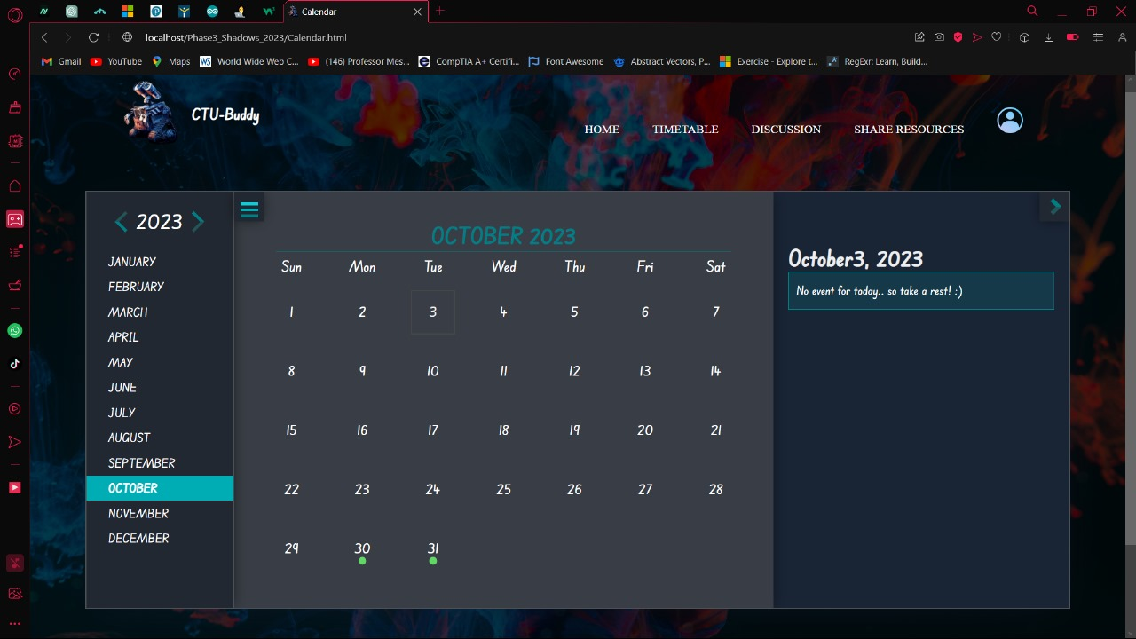

10

9

7

6

5

4

3

2

1

8

1. This wall-e will take you to the home page.
2. This will also take you to the home page.
3. This will take you to the timetable.
4. This will take you to the discussion page.
5. This will take you to the share resources page.
6. This will take you to the profile page.
7. This is where the event of the date will be displayed.
8. This is where you change the months, just click on the month to display it.
9. This is where you change the year. Just click on the arrows.
10. This is how you close the month's panel.

## Timetable

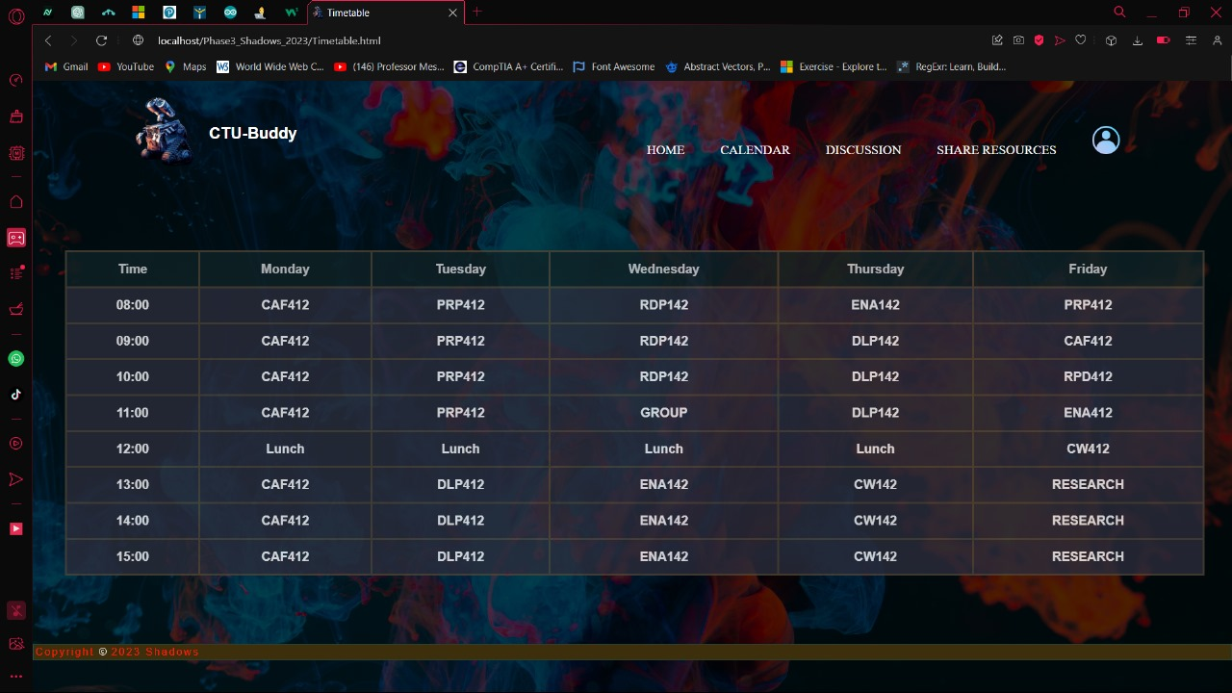

6

5

4

3

2

7

1

1. This wall-e will take you to the home page.
2. This will also take you to the home page.
3. This will take you to the calendar.
4. This will take you to the discussion page.
5. This will take you to the share resources page.
6. This will take you to the profile page.
7. This is the timetable.

## Discussion page

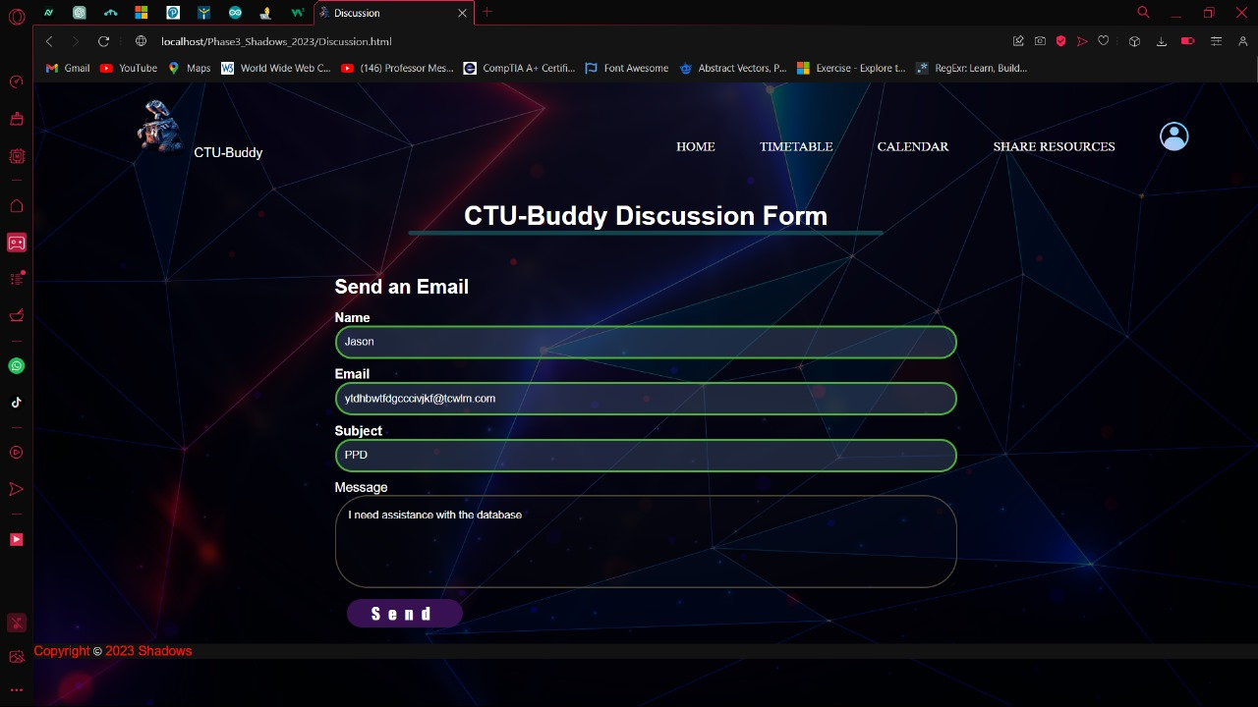

7

6

5

4

3

2

1

1. This wall-e will take you to the home page.
2. This will also take you to the home page.
3. This will take you to the timetable
4. This will take you to the calendar.
5. This will take you to the share resources.
6. This will take you to the profile page.
7. This is where you put the information to start a discussion, the text in the blocks is dummy text. If the discussion is posted successfully it will turn green:
   1. Name: put your first name here.
   2. Email: put your email here.
   3. Subject: put the subject you want to discuss.
   4. Message: put the message here.
   5. Send button: this will post your discussion.

## Share resources page

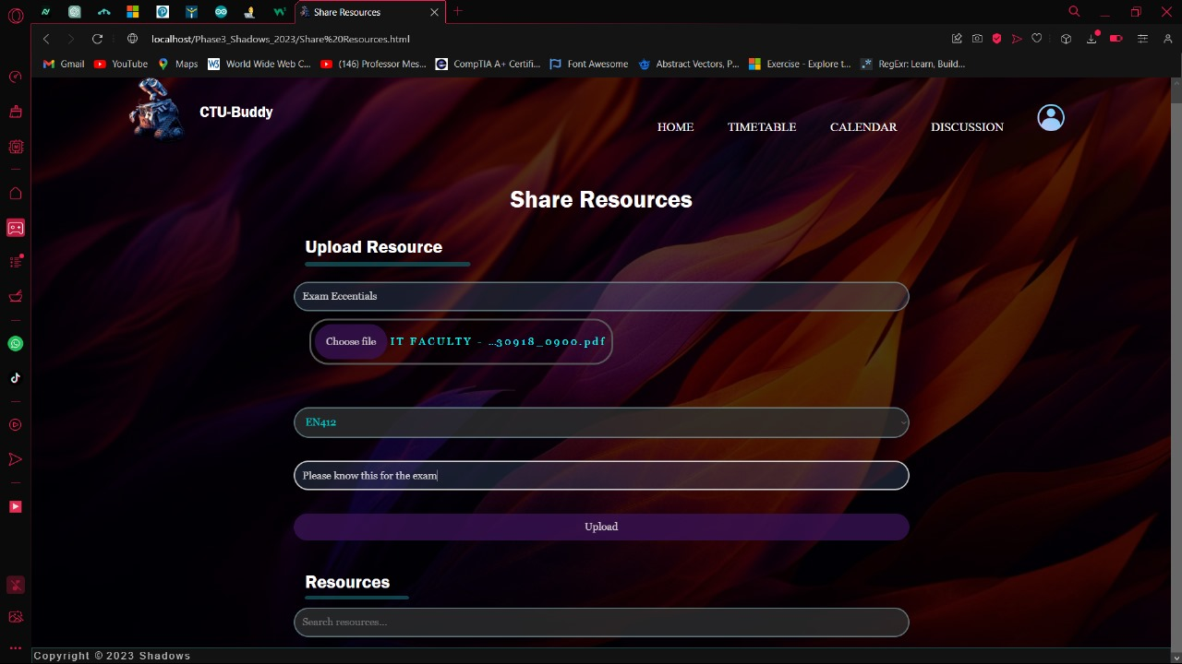

7

6

5

4

3

2

1

1. This wall-e will take you to the home page.
2. This will also take you to the home page.
3. This will take you to the timetable.
4. This will take you to the calendar.
5. This will take you to the discussion page.
6. This will take you to the profile page.
7. This is where you put the details to upload a resource. The text here is dummy text:
   1. Resource name: put your resource name here.
   2. Choose file: choose the file you want to upload.
   3. Category name: put the resource's subject name.
   4. Tags: put the message here.
   5. Upload button: this will upload the resource.
   6. Search resources: this will search for the resource.

If you did everything right the following picture is how it will look.

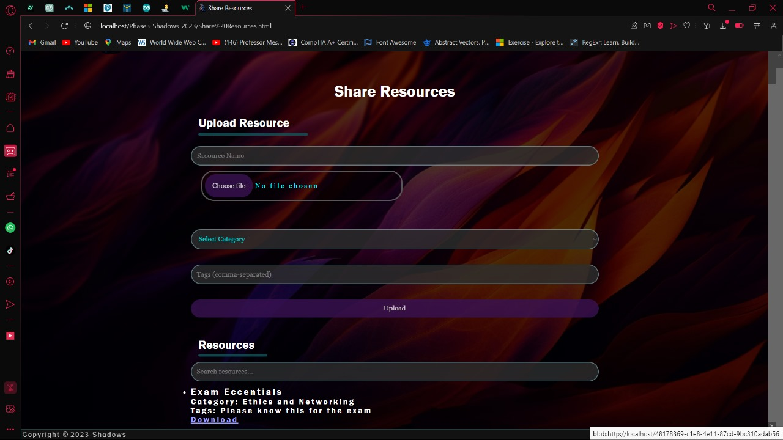

The URL for the website is: <https://shadowctubuddy.000webhostapp.com>

Download the website code Google Drive if this URL does not work.:

<https://drive.google.com/drive/folders/1yxIu7-bgDkNxDDfnYiIn5DzTjSppbOue?usp=sharing>